What are the units of the defocus term of residualwavefront? The KAON claims that the units are microns, but the actual values seem too large:

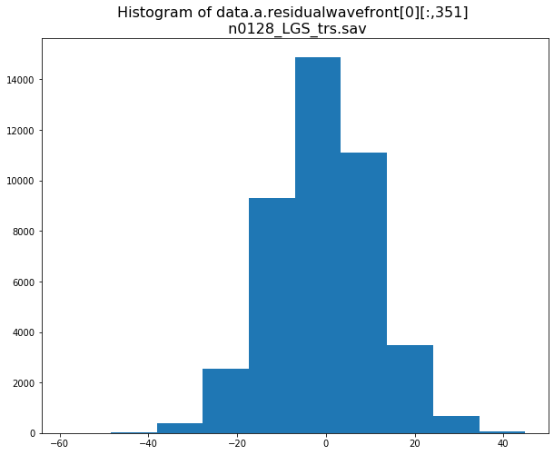

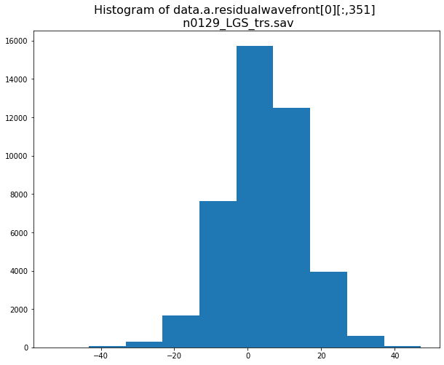

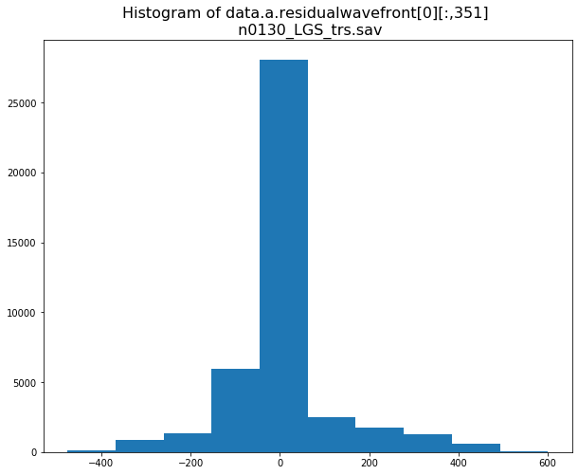

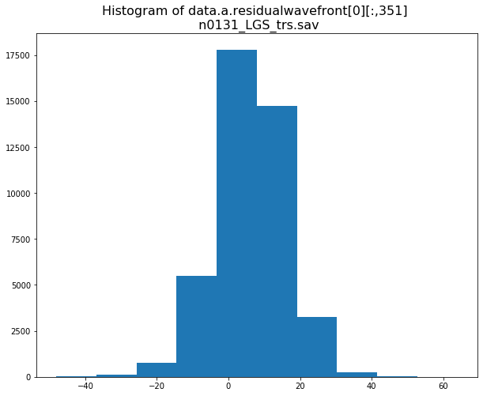

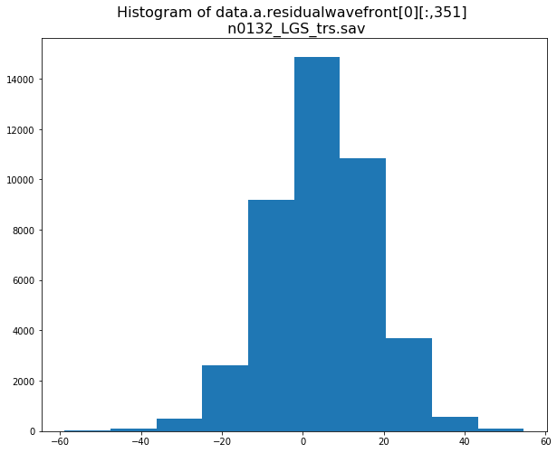

What’s the relationship between data.tstamp_num and the values in data.b.timestamp?

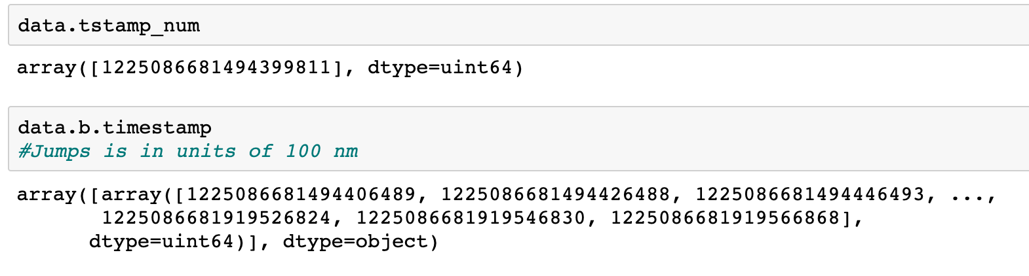

The units of data.b.timestamp should be 100 ns since the beginning of the calendar year

Why are there twice as many residualwavefront values as dttcommands values?

